



**Share**

highs and lows



**Read**

a Bible verse

or story



**Talk**

about how the

Bible reading

might relate to

your highs

and lows



**Pray**

for one another’s

highs and lows



**Bless**

one another

**LATE PENTECOST SEASON 2024, Part One (August 25 – October 12)**

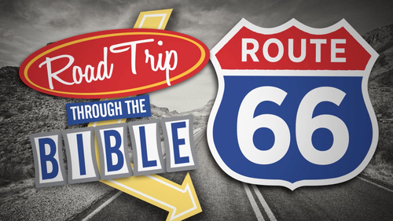

**“Road Trip through the BIBLE”**

Dear Brothers and Sisters in Christ,

**The long season of Pentecost continues through the fall! Let’s spent it on another road trip together through the 66 books of the Bible!** (We also did this in the summers of 2016 and 2021.)

**Such a road trip helps us get a fuller sense of the entire Biblical story and of its overarching themes. It takes us through God’s activity in creation, the lives of the people of Israel, in Jesus’ life and ministry and in the life of His church charged with telling the Good News to the all nations.**

Martin Luther read the Bible through at least twice every year. He said of this: “If you picture the Bible to be a mighty tree and every word a little branch, I have shaken every one of these branches because I wanted to know what it was and what it meant.” Yet, Luther often said he had more to learn from the Bible – so do we!

***What will this look like??***

Over the 14 weeks from August 25 through the end of November we’ll read a verse or short passage from each book of the Bible starting with Genesis! Because we have more than 66 days, we’ll read more than one selection from some books. The devos will still include Sunday gospel readings on Saturdays. We’ll distribute these Devotions in two sets – 7 weeks of passages each time – on August 25 and October 13. They will also be available on the website.

**For your DEVOTIONS:**

**On the back** are the Bible passages for use in your personal or family devotions August 25 through October 12 of the Pentecost season. We invite you to use them in the context of the Faith 5, but however you use them, we hope they enrich your days!

I will continue to post daily verses and a short comment about each on **the Christ Lutheran Church Facebook page** *(**facebook.com/christlutheranchurchdubois**).* Or you can **join our e-mail group** and receive the same daily verses and short comment. Simply send a request message to Pastor Amy at pastorsmiller12@gmail.com.

May your devotions be fruitful and your days blessed. Peace+, Pastor Amy