



**Share**

highs and lows



**Read**

a Bible verse

or story



**Talk**

about how the

Bible reading

might relate to

your highs

and lows



**Pray**

for one another’s

highs and lows



**Bless**

one another

**LATE PENTECOST SEASON 2024, Part TWO (October 13 – November 30)**

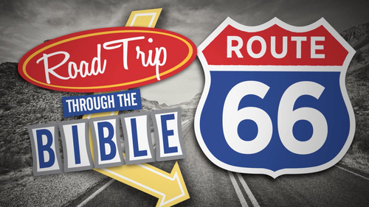

**“Road Trip through the BIBLE”**

Dear Brothers and Sisters in Christ,

**The long season of Pentecost continues through November, and we continue our road trip together through the 66 books of the Bible!**

I hope you have enjoyed our trip so far reading through most of the story of God’s people Israel. In the second half we’ll complete the Old Testament and read parts of Jesus’ life and ministry, and the life of His church charged with telling the Good News to the all nations.

***What will this look like??***

Over the 14 weeks from August 25 through the end of November we are reading a verse or short passage from each book of the Bible starting with Genesis! Because we have more than 66 days, we’ll read more than one selection from some books, including all four Gospels. The devos will still include Sunday gospel readings on Saturdays. We’ll distribute these Devotions in two sets – 7 weeks of passages each time – on August 25 and October 13. They will also be available on the website.

**For your DEVOTIONS:**

**On the back** are the Bible passages for use in your personal or family devotions October 13 through November 30 of the Pentecost season. We invite you to use them in the context of the Faith 5, but however you use them, we hope they enrich your days!

I will continue to post daily verses and a short comment about each on **the Christ Lutheran Church Facebook page** *(**facebook.com/christlutheranchurchdubois**).* Or you can **join our e-mail group** and receive the same daily verses and short comment. Simply send a request message to Pastor Amy at pastorsmiller12@gmail.com.

May your devotions be fruitful, and your days blessed.

Peace+, Pastor Amy