



**Share**

highs and lows



**Read**

a Bible verse

or story



**Talk**

about how the

Bible reading

might relate to

your highs

and lows



**Pray**

for one another’s

highs and lows



**Bless**

one another

**“Five of the Seven**

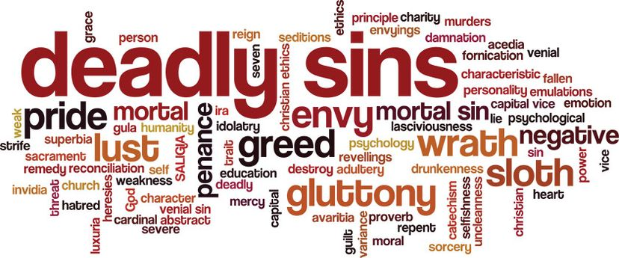

**Deadly Sins”**

**LENT DEVOTIONS, 2025**

Dear Brothers and Sisters in Christ,

The Lenten season, a penitential time to prepare for the great festival of Easter, has been a part of the church since her earliest days. Throughout our pastorate here at Christ Church, we have led several different Lenten disciplines for our congregation: from traditional worship to Bible study, from fellowship and work projects to the Stations of the Cross. This Lent we are going to recommend a slightly different discipline and try something new. Rather than read and preach on the traditional Lenten lessons from the Revised Common Lectionary, we will preach a Sunday series on five of the Seven Deadly Sins: Pride, Envy, Anger, Greed and Gluttony. As a discipline, we will ask our church family to read a little each day that week on the topic from Sunday. We will provide Bible readings and writings from Luther, Bonhoeffer, C.S. Lewis and others to delve deeper into the topic. By practicing a discipline and looking at our own shortcomings, we will prepare our hearts for the joy of the Easter message, which has been the point of Lent all along.

Years ago, the church came up with a list of the Seven Deadly Sins that will ruin your life. Lent is a time to admit and come to terms with the fact that no one is righteous – no not one – as the Bible tells us. We are all tempted by these deadly sins, and when we know and admit our sinfulness, to ourselves and each other, we can stop pretending to be good; pretending that we know what to do. Instead, confessing our sins and receiving God’s forgiveness, we can both prepare our hearts for Easter and step out by the power of the Holy Spirit with a new desire to follow God’s guidelines for living.

This devotion will take us through the weeks from March 2 through April 19. We will spend a week each on: **Pride, Envy, Anger, Greed, and Gluttony**, reading both Bible passages and passages from Christian thinkers and theologians which help uncover each theme’s meaning. The calendar and the printed readings are available at church and can be downloaded from our website. We will post daily readings with brief comments this season on the Christ Lutheran Church Facebook page. Or you can join our e-mail group and receive the same daily readings which we post on Facebook. Simply send a request message to Pastor Amy at pastorsmiller12@gmail.com.

May your devotions be fruitful and your days blessed.

*Peace+, Pastors John and Amy*