



**Share**

highs and lows



**Read**

a Bible verse

or story



**Talk**

about how the

Bible reading

might relate to

your highs

and lows



**Pray**

for one another’s

highs and lows



**Bless**

one another

**EASTER SEASON 2025**

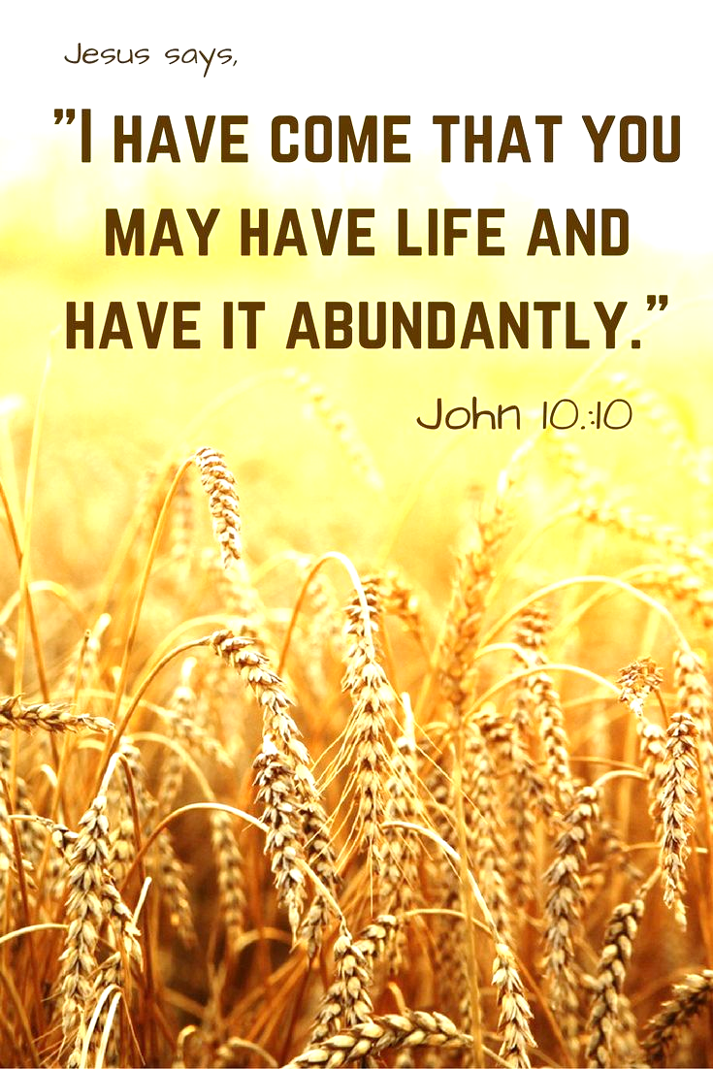

***GOD’S GIFT OF LIFE ABUNDANT!***

Dear Brothers and Sisters in Christ,

Easter is our season to celebrate Jesus’ victory over sin and death; a victory which we all share – new life now and life eternal with our Risen Savior. Our resurrected Lord Jesus appeared over the course of forty days to His disciples and others before He ascended into heaven. The whole season is fifty days, culminating on Pentecost Sunday (day 50!). Pentecost Sunday is an end and a beginning. The risen Christ, having shown himself to his disciples and having ascended, sends the promised gift of the Spirit to the expectant church. The coming of the Spirit gives the church the power and the necessary gifts to carry the glad news of the resurrection from Jerusalem to Galilee to the ends of the earth.

This season in our Easter Faith 5 Devotions let’s read Bible verses that tell us about the gift of new life we receive from our Lord Jesus because of Easter as well as Biblical wisdom about life from the whole Bible story. As we read these passages may we all grow in faithfulness and in our commitment to live the Easter life!

**For your DEVOTIONS:**

**On the back** is a calendar for the whole Easter season devotions, each day with a Bible passage. We invite you to read these verses in the context of the Faith 5, but however you use them, we hope they enrich your days! Each Saturday we’ll read Sunday’s Gospel lesson to prepare us for worship. The calendar is available at church and on our church’s website as well.

I will continue to post daily verses & a short comment about each on **the Christ Lutheran Church Facebook page** *(*[*facebook.com/christlutheranchurchdubois*](http://www.facebook.com/christlutheranchurchdubois)*).* Or you can **join our e-mail group** and receive the same daily verses and short comment. Simply send a request message to Pastor Amy at pastorsmiller12@gmail.com.

May you live the Easter life with joy this season,

Peace+, Pastor Amy